Ein Bild, das Text enthält.

Blended CareerBot training for Career Guidance Practitioner

Learning Agreement

Annex 1 to Module 5

# Training plan – You are here

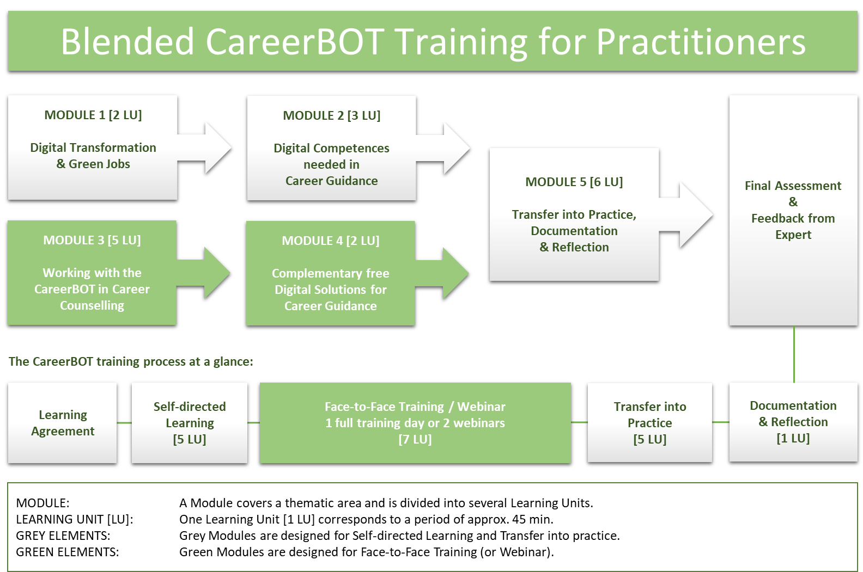

CareerBOT Learning Agreement

between learner and the issuing organisation

|  |  |
| --- | --- |
| Information about the learner (guidance practitioner) | |
| Name of learner |  |
| Organisation |  |
| Address |  |
| Telephone |  |
| E-mail |  |
| Website |  |

|  |  |
| --- | --- |
| Information about the issuing organisation | |
| Name of head trainer |  |
| Organisation |  |
| Address |  |
| Telephone |  |
| E-mail |  |
| Website |  |

|  |  |
| --- | --- |
| Pre-Qualification as Career Guidance Practitioner | |
| **Prior training and practical experience as career guidance officer** | |
| Indicators | Describe your individual pre-qualification |
| Prior trainings as career guidance officer |  |
| Prior practical experience in career guidance |  |

Please annex your CV, preferably in Europass format:

<https://europa.eu/europass/de/create-europass-cv>

|  |
| --- |
| **Personal Motivation and Interest** |
| What do I expect from the CareerBOT training course?  How will I use the CareerBot method for my daily work? |
|  |

**CareerBOT Learning Agreement duly signed by:**

___________________________________________________________________________

Participant in the CareerBOT Training: <Name / Organisation / date and signature:

_____________________________________________

Head trainer: <Name / Organisation / signature and date:



**CC BY-NC-ND**

This document is licensed under CC BY-NC-ND. See: <https://creativecommons.org/licenses/by-nc-nd/4.0/>